**Untitled Project**

INSERT A JPG OF THE MENU SCREEN HERE

**Game Design/Technical Document**

Contents

One Sentence Pitch 2

Aims of the project assignment 2

Functional Requirements 3

Target Audience 3

Narrative 4

Main Concept 4

Proposed Development Approach 5

System Requirements 5

Identification of Required Resources/Software Requirements/3rd Party Tools 5

Storyboards/Concept Artwork/Media Catalogue 6

Visual References 9

Visual Style 11

Lighting 13

Audio Style and Requirements 13

Genre 13

Game Objectives 13

Menu Systems 13

Player Navigation/Controls 13

Gamepad 13

Keyboard 13

Motion Tracked VR Controllers 14

In-Game Information - GUI 14

Character Health 14

Difficulty 14

Missions/Objectives 14

Levelling Up/Power Ups/Perks 14

Power Downs/Debuffs 14

Bosses/Set Piece Events 15

Player to Environment 15

Player to Enemies 15

Multiplayer (Player to Player) 15

Win/Lose Conditions 15

High Scores and Ranking 15

Level Design 15

Level Structure 15

Maps and Level Design 16

Component Descriptions 16

Pseudocode 16

UML/Flowcharts 16

References 16

# One Sentence Pitch

3D, “low poly”, isometric puzzle adventure exploring hunger and death, in a simplified journey to escape the highland clearances.

# Aims of the project assignment

Develop a prototype Windows PC game which complies with the project brief, using a cost and time efficient development strategy.

Exercise various already learned skills related to the development of said game (pitch, planning, programming, asset production, unit testing, conformance testing, etc).

Self-evaluate how the product meets the project brief, at the end of development, in order to ascertain whether the process could have been improved/changed.

Self-evaluate performance of the process at project end, including recommendations for development of future projects, in order to ascertain whether the process could have been improved/changed.

# Functional Requirements

* The game must load and run on Windows PC devices with no errors, hangs or crashes to OS.
* The title screen must display.
* The game should commence upon selecting “start game”.
* The player character moves around upon player input.
* The player character should interact with other game objects upon player input.
* Audio assets should play upon the appropriate events occurring.
* Enemies should spawn and attack the player upon interaction with sheep.
* When the player character interacts with the boat the game should end.
* At game end a final narrative text should be displayed.
* Upon user input the game should revert to the title screen.

# Target Audience

*Target Audience:* Suitable for all age ranges. The assumption that a certain “target audience” (considering demographics like age, gender, country of origin) plays a specific game type is no longer accurate. Looking at Google Play analytics or Steam user analytics shows that people own and play all kinds of games regardless of gender, age and geographic area.

Instead I would suggest that “player types” should be considered as per the image below.

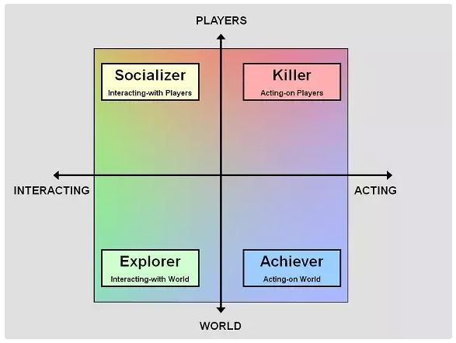

Figure 1 - The new demographic model, courtesy of Bart Stewart

Players of types “Explorer” (interacting with world systems) and “Achiever” (playing to complete the game) will be drawn to this title.

# Narrative

You play as a highlander fleeing the violence and famine of the highland clearances. Travelling ever westwards away from your burnt-out croft, you seek a rowing boat which will allow you to (eventually) escape to the new world.

# Main Concept

UNTITLED PROJECT is a short narrative experience designed to showcase the brutality of the highlanders’ plight during the clearances. The aim of UNTITLED PROJECT is to produce a prototype of the gameplay featuring a low poly, 3D clansman as the player character. User input will be handled by keyboard controls. On screen, a player-controlled highlander travels to the left of the screen, while encountering numerous sheep which flock in a random manner. The player has a hunger meter on a timer which will lead to player death when empty. Each sheep is edible, however interacting with the sheep in any way will immediately summon a squad of redcoats who will then kill you (no defence is possible). Running ever leftwards without interacting with the environment or sheep will lead you to the escape boat. The hunger meter is tweaked to allow for a no-deviations-escape to the west. Any dawdling will starve the player to death.

# Proposed Development Approach

We propose to use the Agile development model in order to fulfil the project brief. We looked at but rejected waterfall and spiral.

Advantages of the Agile model include:

* Rapid, continuous production of software prototypes.
* Interactions between team members are emphasized rather than documentation, processes and tools.
* Working software can be delivered over shorter timescales than by using other methods.
* Adaptation to changing circumstances/ideas.

Disadvantages may include:

* Difficulty in assessing the effort and complexity required at the beginning of the project.
* Lack of emphasis of design and documentation.
* Easier to lose track/needlessly increase scope of the project.
* The dangers of unrealistic expectations with regards to scope, timescale and developer skill.

The waterfall development model was rejected as:

* When testing it is difficult to go back and change something that was de-lineated at the design stage.
* No working software is produced until late in the development cycle.

# System Requirements

Operating System: Windows 7, 8, 8.1, 10

1 GHz or faster processor or SoC

1 GB RAM (32-bit systems) or 2 GB RAM (64-bit systems)

16 GB Hard disk space (32-bit systems) or 20 GB (64-bit systems)

DirectX 9.0c or later GPU with WDDM 1.0 driver

# Identification of Required Resources/Software Requirements/3rd Party Tools

Unity 2018.2.8f1 (64-bit) installed on each developer’s computer.

Visual Studio 2017 installed on each developer’s computer.

Maya 2018 installed on each developer’s computer.

Audacity installed on each developer’s computer.

Access to <https://www.bfxr.net/> for audio production.

Windows PC for testing (various specifications).

# Storyboards/Concept Artwork/Media Catalogue

**Storyboards**

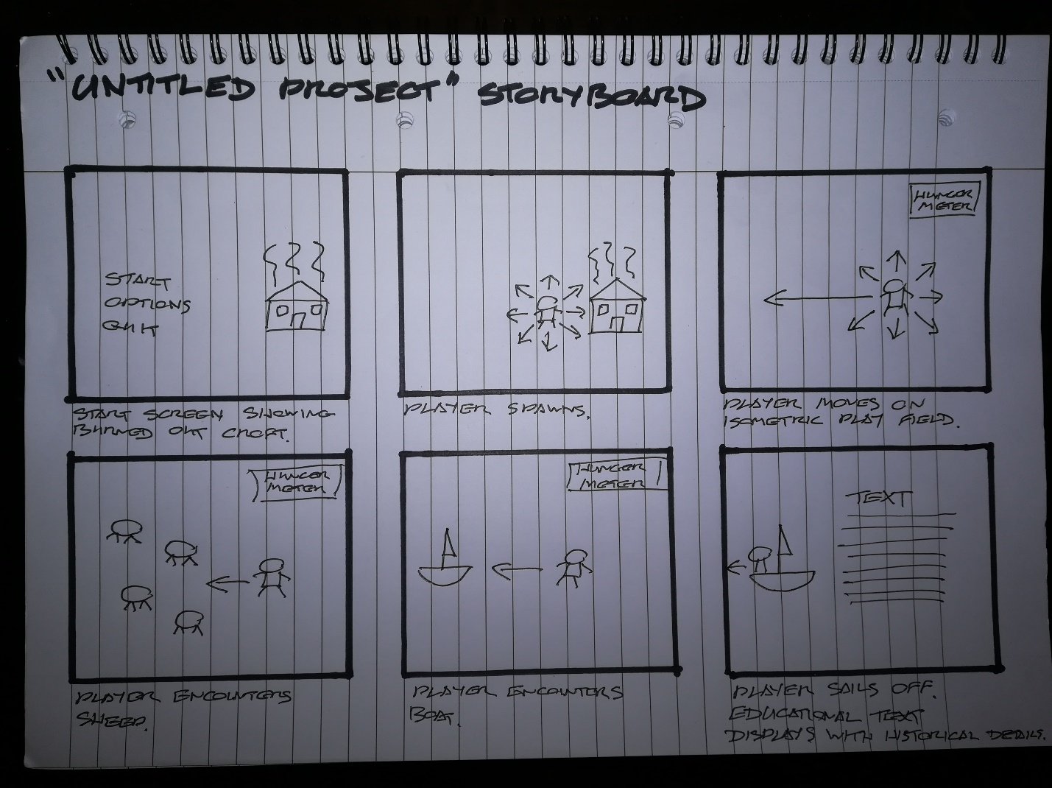

Figure 2 - Storyboard for game flow.

**Concept Artwork**

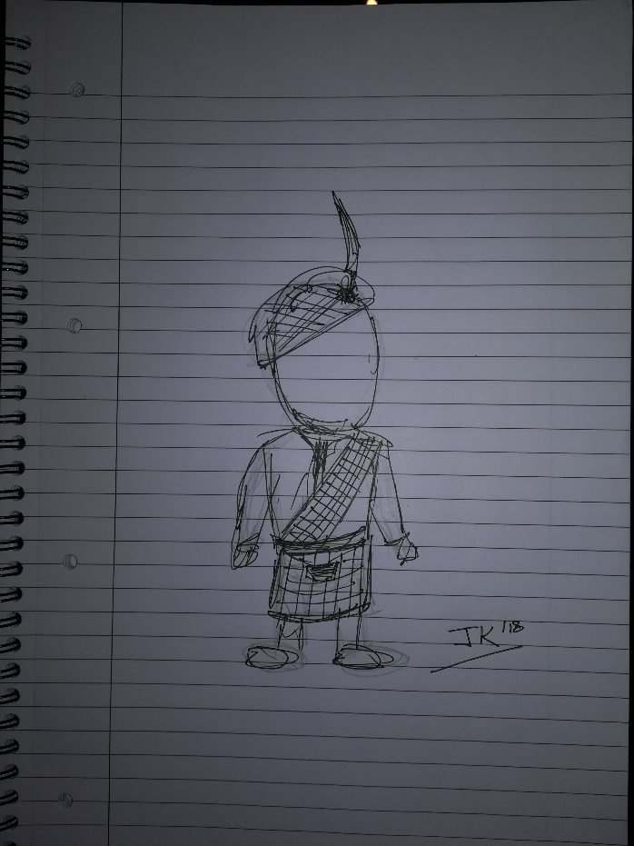

Figure 3 - Protagonist concept.

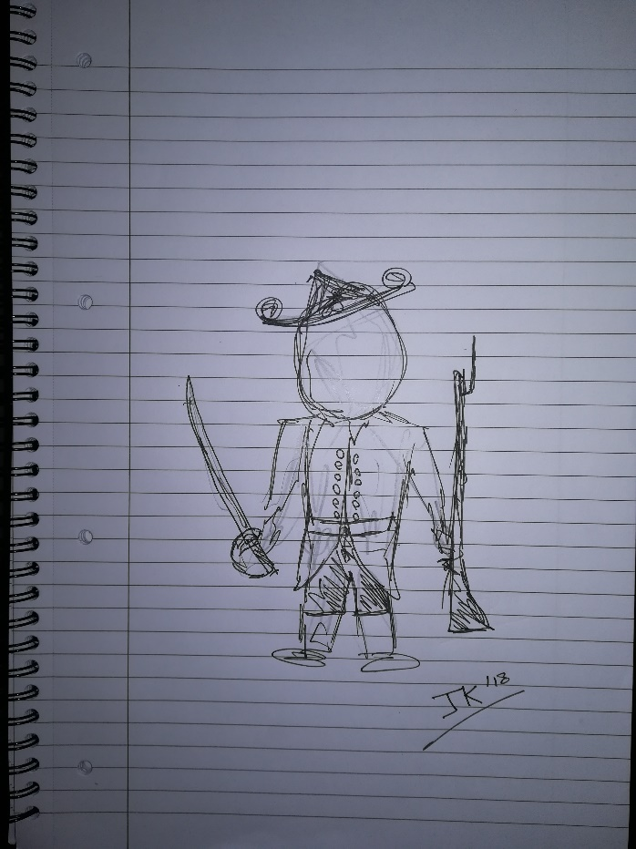

Figure 4 - Redcoat concept.

**Media Catalogue/Production Assets**

Free Low Poly Pack <https://assetstore.unity.com/packages/3d/characters/free-low-poly-pack-65375>

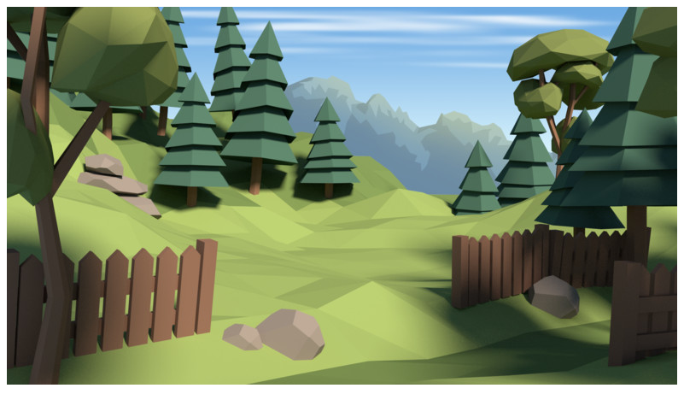

Figure 5 - Example scene from Free Low Poly Pack on the Unity Asset Store

Low Poly Game Kit <https://assetstore.unity.com/packages/templates/packs/low-poly-game-kit-110455>

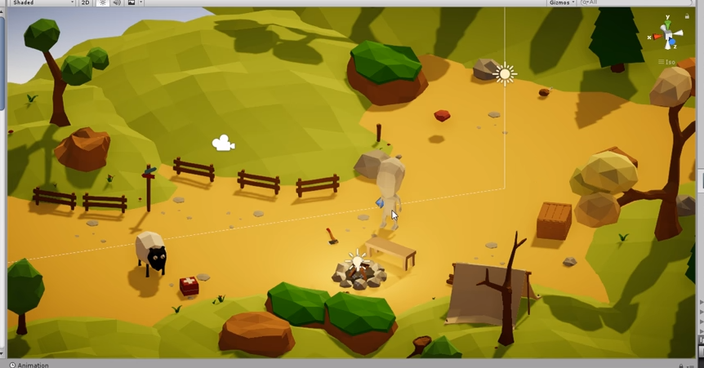

Figure 6 - Example scene from Low Poly Game Kit on the Unity Asset Store

# Visual References

The UNTITLED PROJECT is designed to visually reference the currently in vogue 3D low polygon count “cutesy” prototypes produced by independent game developers such as Twitter user @PunchesBears (https://twitter.com/punchesbears), while the core subject of the game is intended to add a much-needed counterpoint to the cuteness.

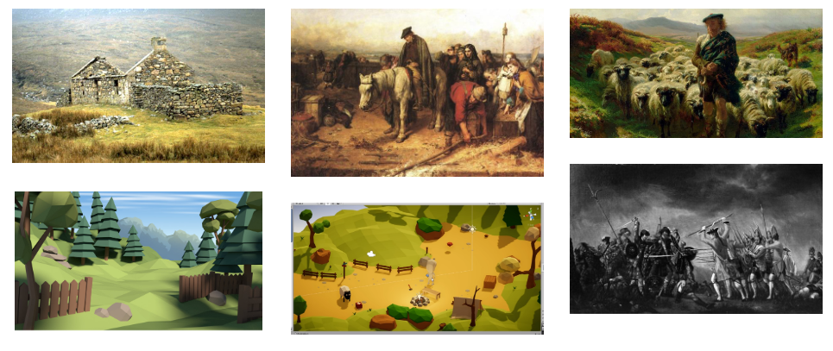

Figure 7 - Mood board courtesy of canva.com

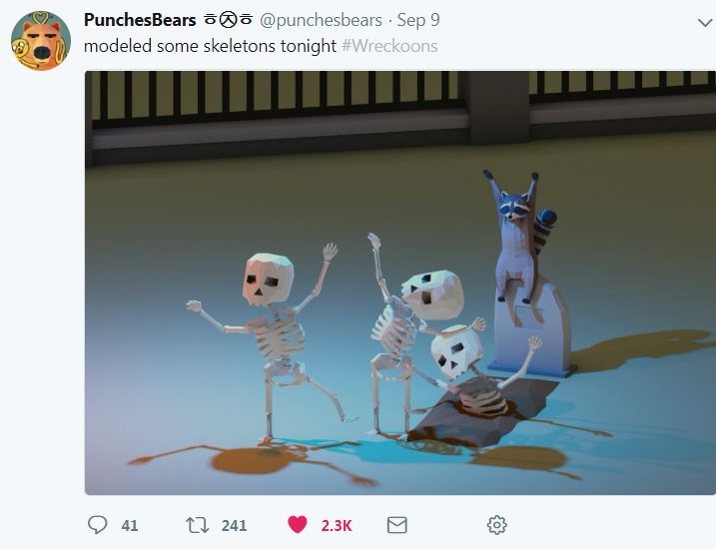

Figure 8 - Low poly, cute. Courtesy of the above Twitter account.

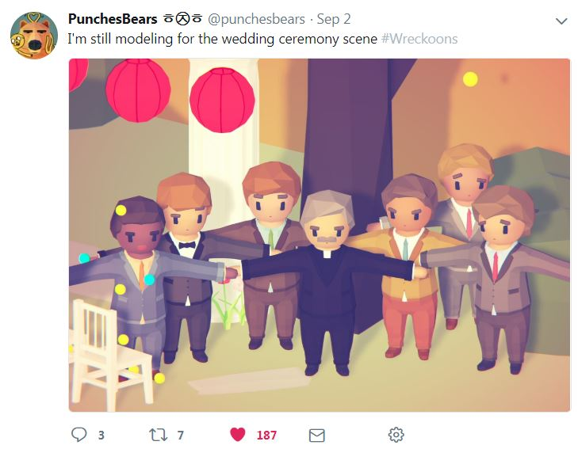

Figure 9 - Note the pastel colour palette and cute, low poly look.

# Visual Style

UNTITLED PROJECT is to be a single-player, 3D side scrolling, minimalistic puzzle adventure, with a cute, modern, low poly art style. A bright and breezy character will interact with a stylised, historical rural scene.

**Colour Palettes**

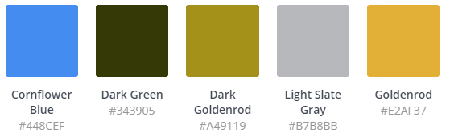

Figure 10 - Palette data courtesy of canva.com

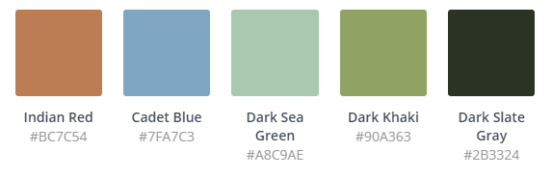

Figure 11 - Colour palette courtesy of canva.com

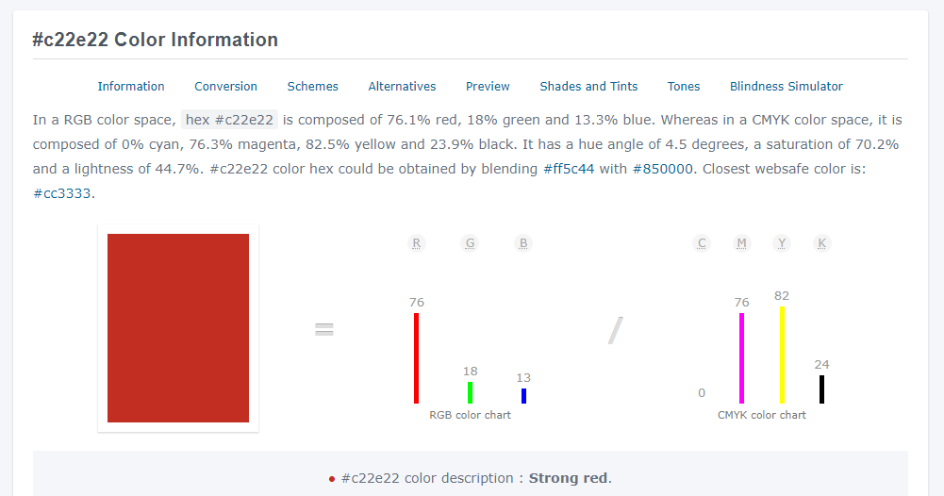

Figure 12 - Colour analysis courtesy of colorhexa.com

# Lighting

It is envisaged that UNTITLED PROJECT should be lit as if in the middle of a clear day. There will be no day/night cycle.

# Audio Style and Requirements

XXX

# Genre

“Experimental” Puzzle Adventure Game.

# Game Objectives

Reach the western shore, get in the boat, and escape to the new world.

# Menu Systems

XXX

Menu colours should be the same as the palette chosen for the main game scene, this will also provide a high contrast UI for colour-blind users.

All on screen UI elements in UNTITLED PROJECT will default to this colour palette.

# Player Navigation/Controls

Primary interaction with the game will be via device keyboard.

# Gamepad

Not applicable.

# Keyboard

Primary interaction with the game will be via the following keypresses:

A – Move left.

D – Move right.

W – Move up.

S – Move down.

F – Interact.

[ESC] – Back.

# Motion Tracked VR Controllers

Not applicable.

# In-Game Information - GUI

The in-game GUI will consist of a graphical icon of a stomach and a hunger bar towards the top right of the screen.

# Character Health

The player has one life which will end with the hunger meter reaching zero, or being shot by redcoats.

# Difficulty

Very Challenging. Designed to be frustrating to the player.

# Missions/Objectives

Head west, find a boat, escape famine.

# Levelling Up/Power Ups/Perks

Not applicable.

# Power Downs/Debuffs

Not applicable.

# Bosses/Set Piece Events

Initial cutscene showing burned out croft, drifting right to prop redcoats.

On alert frustum moves to instantiated redcoats and back to player.

On completion the player character will sail away on a boat and this is the final animation that will complete the game.

# Player to Environment

The player will move around the screen upon keyboard input. The environment will be a moving, low poly terrain.

# Player to Enemies

The player cannot evade the redcoats once they are summoned. Death is certain.

# Multiplayer (Player to Player)

Not applicable.

# Win/Lose Conditions

The player will win by reaching the escape boat.

The player will lose by starving to death or being shot by redcoats.

# High Scores and Ranking

No scoring/ranking system is required.

# Level Design

UNTITLED PROJECT will use a right-to-left designed level, the level will feature natural environments such as trees, rocks, mountains and grass. There will also be sheep scattered throughout the level, which the player must dodge to stay alive. At the end of the level is a boat and an oceanic view, which is how the player escapes from the Red Coats.

# Level Structure

XXX

# Maps and Level Design

XXX

# Component Descriptions

XXX

**Main Menu Components**

Play Button – This button allows the player to start the main scene. The main scene is also the playable game.

Settings Button – This button will allow the player to go to a settings screen to adjust the volume of the music in the game.

Quit Button – This button allows the player to quit the game and end all processes.

Background - XXX

# Pseudocode

XXX

# UML/Flowcharts

XXX

# References